Skill 7

- Process Synchronization and Child Process Monitoring Using waitpid().

To Retrieve PATH Variable, Parse Search Directories, Locate Executables, Verify Permissions, Handle Missing Commands, Test Command Resolution.

Code:-
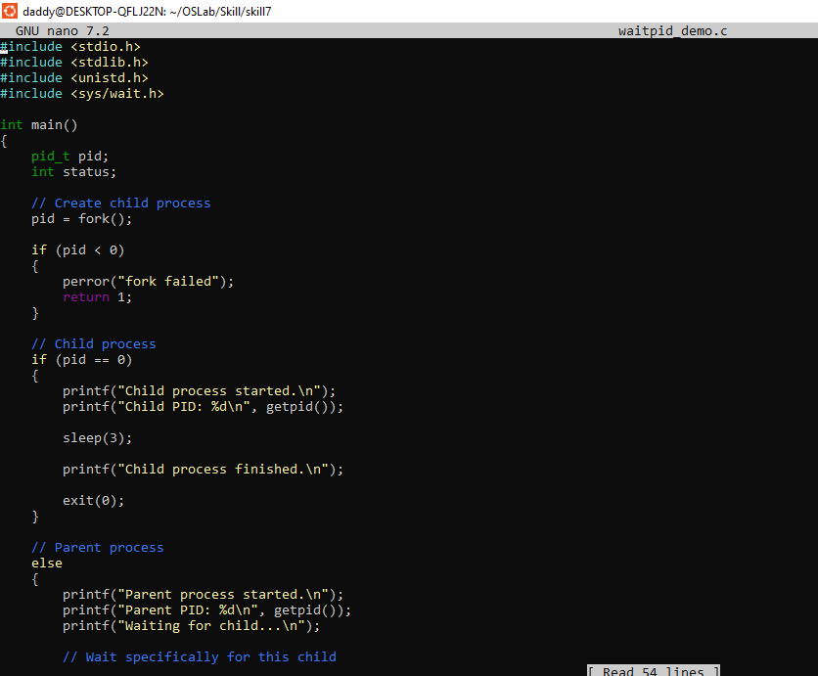
Output
